COVID CLINIC PATIENT HANDOUT AND INSTRUCTIONS
ChoiceMMed Pulse Oximeter Instructions

Pulse oximeters measure your oxygen level (SpO2% or O2) and your heart rate, also called pulse rate (PRbpm or PR). Use the table to record your measurements.

Your care team will let you know what oxygen levels are acceptable for you. If your levels remain lower than expected, if possible, please let someone in your home know and **see instructions on when to go to the ER (emergency room)**

- Open the clamp gently and slide the second or third finger into the oximeter:
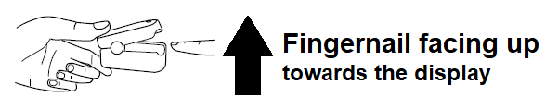
- With the finger well placed into the oximeter, press the front button to turn it on.

- The oximeter will display “— —” for SpO₂ % and “— — —” for PRbpm. Keep your hands still for the reading. Wait a few seconds, a waveform will appear on the display which shows that the oximeter is taking a measurement. Then, the oximeter will display the SpO2% and PR (pulse rate) values.

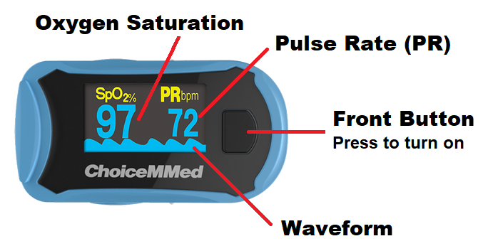

- Wait 15-30 seconds for SpO2% (oxygen level or O2) and PR (pulse rate) values to stabilize. Then, read and record the data from the display screen onto the table provided.

- Remove finger from the oximeter. After 8 seconds, the device will automatically turn off.
Notes:
- The finger placed into the oximeter should NOT have nail polish or false fingernail. It should be clean and relatively warm (good circulation).
- If the screen displays “?”, it means the signal is unstable. Do not clench your fist/ relax your hand, and keep your hand still. Make sure that your finger is all the way inside the oximeter. Try another finger if it is not reading.
- If the display mode changes and is not the default display mode as shown above, remove finger from the oximeter and wait 8 seconds for it to turn off. Try again from step 1.
- Cleaning- please do not get the oximeter wet. Wipe with a small alcohol wipe if available. Do not use other disinfecting wipes as they may damage the display.

